STATEMENT OF WORK

BOARDWALK CONSTRUCTION AT PARKING LOT A1

CHINOTEAGUE NATIONAL WILDLIFE REFUGE

PART A – GENERAL INFORMATION

GENERAL DESCRIPTION:

Furnish and install wood boardwalks at Parking Lot A1 at the Chincoteague National Wildlife Refuge (NWR), 8231 Beach Rd, Chincoteague, VA 23336. The work shall be constructed per the drawing details included in the supplied design drawings, which are being furnished as a separate attachment.

Base quote item number one is to furnish and install an elevated wood boardwalk, with overlooks, seating access, staircases, and handrails as specified.

Additive quote item number two is to furnish and install 6 feet wide on grade boardwalks as specified. There are 2 boardwalks required that are each approximately 500 feet long.

In the Appendix to this document, it is shown that construction work is required for elevated boardwalk at Parking Lot A1, location number 2. Also construct on grade boardwalks at Parking Lot A1, location numbers 1 and 3.

The set of drawings that accompany this statement of work shall be used. Note that the drawings are to be used for the general locations to install the boardwalk. The actual boardwalk locations and construction alignment in the field shall be coordinated with on-site refuge personnel. feet

General refuge hours are 6 AM to 6 PM Monday to Friday.

CONTACT INFORMATION:

Prospective contractors are encouraged to contact Richard_yee@fws.gov, or robert_leffel@fws.gov; for additional information or site specific requirements. A site visit to assess the work conditions is recommended. The use of Microsoft Teams is the other method to contact the personnel listed.

PART B – CONSTRUCTION REQUIREMENTS

ELEVATED WOOD BOARDWALK

Construct the elevated boardwalk, which includes overlooks Type A and Type B, and two seating access areas and required staircases.

Construct the elevated boardwalk and staircases per the details shown in the drawings shown in the attachment.

The installation shall also be coordinated in the field with the Refuge staff. Alignment and other adjustments may be made in the field with the concurrence of on site Refuge personnel.
The boardwalk lumber shall comply with American Wood Protection Association (AWPA) Standard UC5C standards for the specifications for preservative treated wood for marine use, brackish water areas.

Construct the boardwalk platform per the boardwalk details shown in the drawings shown in the attachment. The lumber stringers, wood decking, timber pile details, and handrail details shall be used.

WOOD MATERIALS REQUIRED FOR ALL THE BOARDWALKS, STAIRCASES, PLATFORMS, AND BENCHES

The wood boardwalks, platforms, staircases, benches, and all associated work shall use the following materials.
a. Furnish Type 304 or Type 316 stainless steel hardware. Furnish stainless steel bolts and washers conforming to ASTM A193, and stainless-steel nuts conforming to ASTM A194.
b. All lumber shall comply with American Wood Protection Association (AWPA) Standard UC5C standards for the specifications for preservative treated wood for marine use, brackish water areas.

c. Lumber shall be southern pine or approved equal.

d. Treated lumber must have a quality mark approved by the American Lumber Standards Committee for individual pieces assuring that treatment conforms to the appropriate AWPA standards.

ON GRADE WOOD BOARDWALK

The boardwalk lumber shall comply with American Wood Protection Association (AWPA) Standard UC5C standards for the specifications for preservative treated wood for marine use, brackish water areas.

Construct the boardwalk per the details shown in the Appendix in this document, and the drawing attachment.

Boardwalk shall be installed at the areas shown in the plan in the Appendix. The installation shall also be coordinated with the Refuge staff, and at areas recommended by the Refuge staff. Alignment and other adjustments may be made in the field with the concurrence of on-site Refuge personnel.

PART C - SAFETY
The Contractor shall be responsible for compliance with all provisions of Occupational Safety and Health Administration and all State, Local, and Federal requirements.
(OSHA) requirements, CODE OF FEDERAL REGULATIONS (CFR):
a. 29 CFR 1910 Occupational Safety and Health Standards (OSHA)
b. 29 CFR 1926 Safety and Health Regulations for Construction

PART D – MATERIAL SUBMITTAL REQUIREMENTS

A. Furnish manufacturers information that indicate that the materials being furnished comply with the material requirements of these specifications.
B. The material submittals shall be approved by the Government before the materials are installed.

APPENDIX

Boardwalk locations at site item numbers 1, 2, and 3.
On grade boardwalk details.

SEPARATE DRAWING ATTACHMENT

Boardwalk plans and details, 8 pages

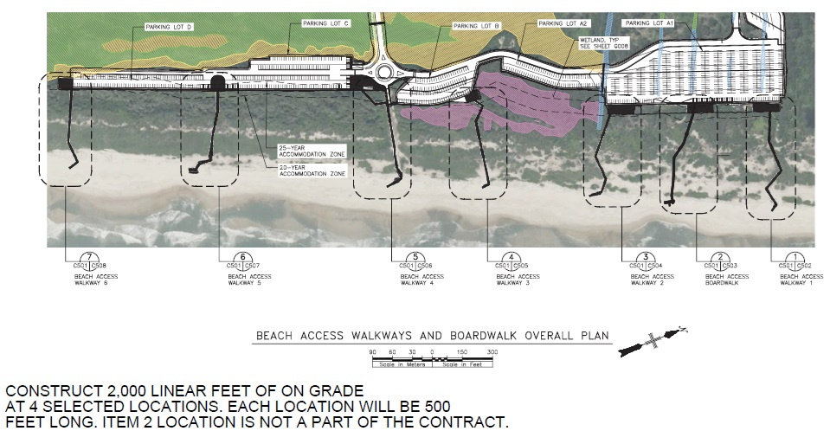

Boardwalk locations at site item numbers 1, 2, and 3.

Construct elevated boardwalk at Parking Lot A1, location number 2.

Construct on grade boardwalks at Parking Lot A1, location numbers 1 and 3.

The other on grade boardwalks (numbers 4, 5, 6, and 7) shown are not a part of this contract.

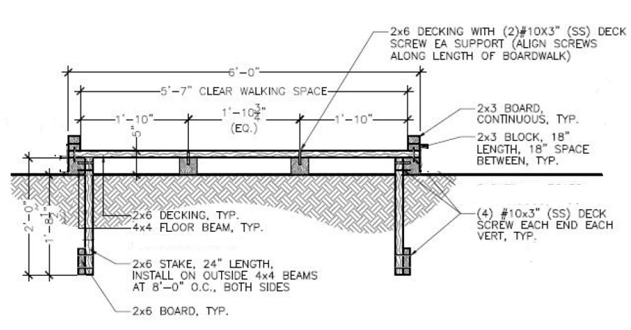
On grade boardwalk details.

Elevation view of on grade boardwalk

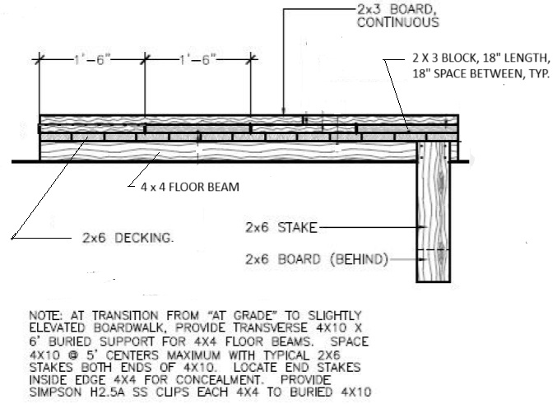

End view of on grade boardwalk

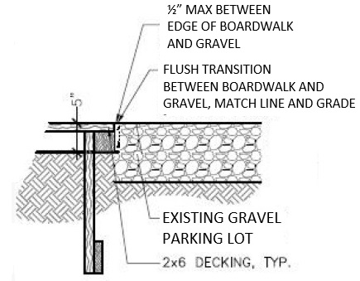
End view of on grade boardwalk at gravel parking lot transition areas

