CAPE HATTERAS NATIONAL SEASHORE
Buxton, North Carolina

STATEMENT OF WORK:

Replace Septic Tank and Drainfield at Buxton Quarters 321&323

NATIONAL PARK SERVICE
Region 2
CAPE HATTERAS NATIONAL SEASHORE

Outer Banks Group

Statement of Work

Replace Septic Tank and Drainfield at Buxton Quarters 321&323

- INTRODUCTION

The National Park Service (NPS) Cape Hatteras National Seashore (CAHA) has a requirement
to replace the septic tank and drain field at Quarters 321 & 323 on Cabin Rd in Buxton, NC.

- CONSTRUCTION SITE LOCATION

The address for the project site is 46020 Cabin Rd Buxton, NC 27920.

- BACKGROUND AND EXISTING CONDITIONS

The four historic cabins are located on Cabin Road in Buxton NC. The units were originally built in the 1930s as housing for members of the Civilian Conservation Corps. The cabins are listed on the National Historic Registry and are treated to historic architectural standards of practice when repairs and renovations are required. Each cabin includes a main living space, kitchen and bathroom. Q321 and Q323 are each 1 bedroom homes. The below tables approximate the square footage of each house.

Cabin Number | Total SF
321 | 380
323 | 494
The site was examined according to North Carolina Administrative Code Title 15A Chapter 18 Environmental Health Subchapter 18E Sanitation - Sewage Treatment and Disposal Systems (15A NCAC 18E). Specifically, the topography, landscape, soil characteristics, soil wetness condition and water table depth, soil depth and restrictive horizons, daily flow rate, and setbacks for the location of tank and drainfield. A 2” diameter hand boring was made to a depth of 4 ft. Soil was found to be dry with no indication of wetness due to the water table. The soils discovered include poorly graded, consistent yellowish to light brown sand: Type I Loamy Sand suitable for drainfields with no restrictive layer or limiting condition.

Consultation with the Dare County Public Health On Site Water Protection Branch provided helpful information on the Long Term Acceptance Rate of 1.0, acceptable innovative technology infiltration systems, and calculation for overall drainfield layout. The minimum size tank allowed by 15A NCAC 18E for residential 3 bedroom homes is 1,000 gal. The Daily Design Flow (DDF) for the two 1 bedroom homes is 120 gal / bedroom = 240 gallons per day. The calculation for the size of this drainfield using DDF of 240 gal/day, LTAR of 1.0 gal/day/sf, 3 ft wide trenches using the approved innovative technology for a 25% reduction in overall trench length when using recommended separation of 3 times the trench width is:

Infiltration trench overall length = (240 / 1.0 / 3) *.75 = 60 ft.

Acceptable drainfield is 2 trenches at 30 ft long at 9 ft on center

The existing septic tank and drainfield is located in front of Q321. Septic wastewater from Q323 drains from the home down a slope and into the tank near Q321. A wooden porch with two steps and a wooden boardwalk lead from the front door of Q321 to an existing paved parking area. The yard in front of Q321 is generally flat around the home, and slopes downward away from the home.

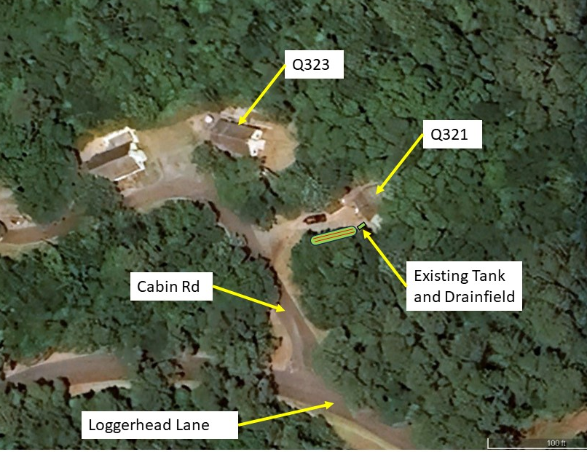
Figure 1: Aerial photo of project site along Cabin Rd in Buxton.

- SCOPE OF WORK

Replace the septic system with a new septic system meeting the most current version of 15A NCAC Subchapter 18E and International Building Code for North Carolina. A qualified installer with a State approved license shall install the new system.

- Task 1: Submit Product Data for materials to be used on this project.
- Task 2: Locate and mark existing utilities within the limits of construction and access route including at a minimum:
  - Water
  - Communications
  - Septic
- Task 3: Demo existing septic system
  - Demo concrete septic tank and distribution tank, approximately 1,000 gal
  - Demo existing drainfield
  - Cut and remove the existing drain line from the house to the septic tank approximately 7 ft from the house (see attached drawings). Protect the remaining end of the existing drain line for reconnection to the new tank.
  - Remove roots within the proposed drainfield trench footprint. Roots larger than 1 inch in diameter shall be pulled back to 5 ft away from the trench and cut and removed. Roots from surrounding trees which are identified on the attached sketch to remain but which extend into the footprint of the drainfield shall be cut at the perimeter of the proposed drainfield (5 ft from the edge of the trench).
  - Remove unsuitable soil from new trenches (approximately 10 cy). Unsuitable soil is defined in 15A NCAC 18E including soil with chroma 2 on the Munsell Soil Color Book. Unsuitable soil may be reused to backfill existing tank excavation, or spread on site to smooth out ruts. Existing gravel materials may remain in place.
- Task 4: Cut and carefully remove wooden walkway.
  - Cut a section of the existing wooden walkway, approximately 36 linear feet, at the location of the new drainfield. Temporarily set the walkway section to the side away from the drainfield to install the drainfield trench.
  - Coordinate the temporary removal and resetting of the wooden walkway with the COR.
- Task 5: Install construction fence around the project site and tree protection fence around existing trees within the project area which are to remain after work is complete. Tree protection fence shall be installed at the drip line of the branches.
- Task 6: Provide new 1,000 gallon concrete septic tank. Locate new tank approximately 7 ft from the house. (See attached sketch of proposed layout of new drainfield).
  - Connect the existing drain line from the house to the new septic tank with waterproof connection.
  - Provide properly sealed joints and connections from the existing drain pipes to new sections of pipe which seal to the new septic tank. Use schedule 40 PVC or approved equal material.
- The new 1,000 gal septic tank include at a minimum:
  - Water tight joints
  - Concrete baffles
  - Effluent filter
  - Access opening less than 18 inches from the end of the tank to visually see the inflow pipe.
  - Adequate opening less than 12 inches from the effluent filter to be able to visually see and physically reach the effluent filter without entering the tank.
  - Access opening to visually see the concrete baffle.
  - Provide HDPE risers and riser lids which extend a minimum of 8 inches above grade. Riser lids shall be locking or mechanically sealed.
- Task 7: Provide new distribution tank and infiltrator drainfield. Drainfield shall be a minimum of 60 LF of new drain lines (two trenches at 30 ft each), 36 inch wide trenches, and 9 ft on center.
  - The new drainfield trenches may be no closer than 5 ft from the top of the slope of the yard in front of Q321. The Contractor shall coordinate the location of the top of the slope with the COR and determine the appropriate location for the new drainfield trenches.
  - Turn existing soil which overlaps with old drainfield area to mix and aerate soils. Provide up to 10 cy new suitable soil within the drainfield trenches. Suitable soil shall be Type I Sand or Loamy Sand obtained from a local source (within 50 miles of the site) defined by 15A NCAC 18E.
  - Provide 36 in wide infiltrator type septic drainfield sections similar to Infiltrator Water Technologies Quick4 Equalizer 36 or Equal which provide a minimum overall length of 60 LF of infiltration drain lines. Low profile sections with lower capacity are not acceptable without increasing trench length.
  - Install chambers according to manufacturer’s installation instructions at least 18 inches above the water table. Provide filter cloth above infiltrator sections according to the manufacturer’s instructions for the brand name utilized.
- Task 8: Reset the wooden walkway.
  - After drainfield installation, reset the walkway in place and connect flush to the existing boardwalk.
  - Scab or otherwise connect the original walkway and the reset walkway using treated 2x4, overlapping at least 6 inches on each side of the cut line, both sides of the walkway.
  - Ensure the ground beneath is appropriately compacted and leveled.
  - Ensure the walkway surface has a flush connection between the joints of the reset. Remove and reset walkway decking at the joint of connection to ensure a level and flush connection.
  - Backfill along the edges of the walkway to prevent a drop-off on the sides of the walkway to the ground.
- Task 9: Provide seeding to the disturbed area, including demolished drainfield, new drainfield, and ruts or other disturbance created by construction. Continue to water the grass until 75% of the area has seeded and growing.
    - Seed shall be suitable for the following:
      - Mostly shade location
      - Residential lawn
      - Mowing operations with hand operated push or riding mowers
      - Sandy soils
      - Septic Field coverage (roots that do not grow deeper than 24 inches)
      - No weeds (dandelion, bahai, pennywort)
      - No exotic species.
    - Broadcast or Hydroseed. Add a cover crop of grain rye at 30 lbs/acre. Rake broadcasted seed mix into the soil and saturate with water 2 – 3 times per day for 7 days, or until 75% of the area has seeds germinated and growing at least 1 inch high. Hydroseeded area may be observed for 7 days or until 75% of the area has growing seeds. If after 7 days, the area is less than 75% covered with new growth, overseed again and water 2-3 times per day until 75% of the ground is covered with growth.

NOTES:

- The Contractor is responsible for marking utilities in the vicinity of the project site.
- The Contractor must track demolition debris which are removed/recycled and provide NPS with receipts showing the weight and volume and type of material removed/recycled as part of this project.
- No construction debris will be allowed to be left on premises. All public areas will remain clean and passible during normal business hours. During business hours, the contractor will ensure that no music is playing in the work areas and no foul language will be tolerated during or after business hours. Work on this project will be accomplished within the hours of 7:00 AM to 5:00 PM Monday thru Friday.

- GOVERNMENT FURNISHED PROPERTY

- No Government property, materials, or equipment will be provided. Water and electricity on the exterior of the existing house is available for Contractor use during this project. Contractor is responsible for lockout/tagout. Contractor is responsible for cleaning up site daily, and for repairing ruts created in grass areas. Ruts shall be filled in or raked smooth before final acceptance of the project.

- SUBMITTALS

- Work schedule: delineating the various stages of work by phase (milestones) prior to the preconstruction conference.
- Safety Plan/Accident Prevention Plan prior to the preconstruction conference.
- Product Samples. The Contractor shall submit written documentation or color/product samples for materials identified in the Scope of Work.
  - Qualification information for Installer.
  - Septic Tank product data
  - Septic Drain Field Infiltrator product data
  - Manhole/Riser data
  - Seed Mix

